Software Construction

and Development
Experiment 02
Conversion of UML Diagrams to Source Code

CLO 1: Apply software construction principles, object-oriented concepts, and UML modeling techniques to design and represent software system structure and behavior using appropriate tools and standard practices.

CLO 2: Design and implement original solutions to given software problems by applying modeling, design, and construction techniques discussed in the lab.

CLO 3: Demonstrate effective teamwork and individual contribution during software modeling and construction activities to develop well-structured and understandable software designs.

Course Instructor: Dr. Mariam Nawaz

Lab Instructor: Dr. Nazia Bibi

1. Aim
To design a UML Class Diagram for a System and converting the UML diagram into equivalent Java source code.

2. Software Requirements
- UML Tool: StarUML / PlantUML
- Java Development Kit (JDK)
- IDE (Optional): Eclipse / IntelliJ / NetBeans
- Operating System: Windows / Linux / macOS

3. UML Class Diagram
A UML Class Diagram represents the static structure of a system by showing:
- Classes
- Attributes
- Methods
- Relationships between classes

UML to Java Code Conversion
Each UML element is mapped to a Java construct as shown below:
UML Element | Java Equivalent
Class | Class
Attribute | Instance variable
Method | Member function
+ Public | Public
- Private | Private
Association | Object reference

Scenario : Design a UML class diagram for a Student and Course system and generate a Java code from the UML diagram.

4.1 UML Diagram Description
- Student class stores student details
- Course class stores course information
- A Student is associated with a Course

4.2 UML Class Diagram (PlantUML Representation)
(This diagram can be rendered using PlantUML or recreated visually in StarUML and pasted into Word)
+-------------------+ +-------------------+
| Student | | Course |
+-------------------+ +-------------------+
| - studentId : int | | - courseName :String |
| - name : String | | - courseCode :String |
| - age : int | +-------------------+
+-------------------+ | + showCourse():void |
| + displayDetails():void | +-------------------+
+-------------------+
|
| Association
|
v
Course

(Optional) PlantUML Code
@startuml
class Student {
- studentId : int
- name : String
- age : int
+ displayDetails() : void
}

class Course {
- courseName : String
- courseCode : String
+ showCourse() : void
}

Student --> Course
@enduml

4.3 Steps to Convert UML Diagram to Java Code
Example 1:
Step 1: Create a class diagram in StarUML
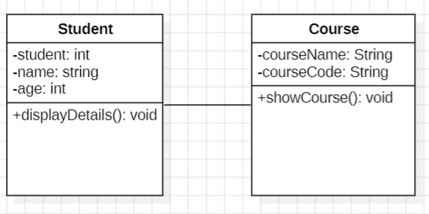
Step 2: Generate Code
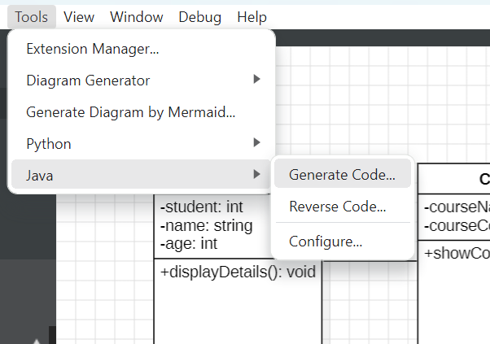
Step 3: Select model and folder where you want to store the code
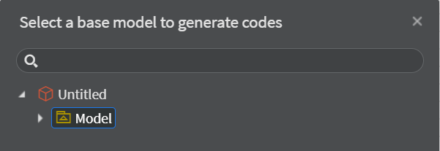


Step 4: View code
Course:
public class Course {
private String courseName;
private String courseCode;

// Default constructor
public Course() {
this.courseName = "Unknown";
this.courseCode = "N/A";
}

// Parameterized constructor
public Course(String courseName, String courseCode) {
this.courseName = courseName;
this.courseCode = courseCode;
}

// Method to display course details
public void showCourse() {
System.out.println("Course Name: " + courseName);
System.out.println("Course Code: " + courseCode);
}

// Getters and Setters
public String getCourseName() {
return courseName;
}

public void setCourseName(String courseName) {
this.courseName = courseName;
}

public String getCourseCode() {
return courseCode;
}

public void setCourseCode(String courseCode) {
this.courseCode = courseCode;
}

// Main method to test the class
public static void main(String[] args) {
// Create course objects
Course c1 = new Course("Mathematics", "MATH101");
Course c2 = new Course("Physics", "PHY101");

// Display course info
c1.showCourse();
System.out.println(); // empty line
c2.showCourse();
}
}

Student:
public class Student {

private int studentId;
private String name;
private int age;
private Course course; // Association with Course

// Default constructor
public Student() {
}

// Parameterized constructor
public Student(int studentId, String name, int age, Course course) {
this.studentId = studentId;
this.name = name;
this.age = age;
this.course = course;
}

// Getters and setters
public int getStudentId() {
return studentId;
}

public void setStudentId(int studentId) {
this.studentId = studentId;
}

public String getName() {
return name;
}

public void setName(String name) {
this.name = name;
}

public int getAge() {
return age;
}

public void setAge(int age) {
this.age = age;
}

public Course getCourse() {
return course;
}

public void setCourse(Course course) {
this.course = course;
}

// Method to display student details
public void displayDetails() {
System.out.println("Student ID: " + studentId);
System.out.println("Name: " + name);
System.out.println("Age: " + age);
if (course != null) {
System.out.println("Course: " + course.getCourseName());
} else {
System.out.println("Course: Not assigned");
}
}

// Main method to test Student class
public static void main(String[] args) {
// Create Course objects
Course c1 = new Course("Mathematics", "MATH101");
Course c2 = new Course("Physics", "PHY101");

// Create Student objects
Student s1 = new Student(1, "Ayesha", 20, c1);
Student s2 = new Student(2, "Samia", 22, c2);

// Display details
s1.displayDetails();
System.out.println();
s2.displayDetails();
}
}

Step 5: run the code

Output :

Example 2:Creation of main method inside a class

In this example, we have created a Student class which has two data members id and name. We are creating the object of the Student class by new keyword and printing the object's value.

Here, we are creating a main() method inside the class.
//Java Program to illustrate how to define a class and fields
//Defining a Student class.
class Student{
//defining fields
int id;//field or data member or instance variable
String name;
//creating main method inside the Student class
public static void main(String args[]){
//Creating an object or instance
Student s1=new Student();//creating an object of Student
//Printing values of the object
System.out.println(s1.id);//accessing member through reference variable
System.out.println(s1.name);
}}

File: Student.java

output

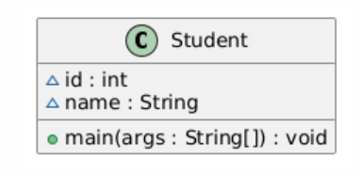

Example 3 : Object and Class Example: main outside the class:In real time development, we create classes and use it from another class. It is a better approach than previous one. Let's see a simple example, where we are having main() method in another class.

We can have multiple classes in different Java files or single Java file. If you define multiple classes in a single Java source file, it is a good idea to save the file name with the class name which has main() method.
//Java Program to demonstrate having the main method in
//another class
//Creating Student class.
class Student{
int id;
String name;
}
//Creating another class TestStudent1 which contains the main method
class TestStudent1{
public static void main(String args[]){
Student s1=new Student();
System.out.println(s1.id);
System.out.println(s1.name);
} }

File: TestStudent1.java

Output

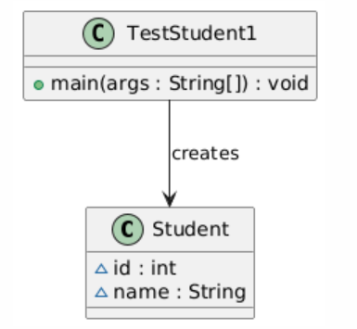

Example 4: Let's see an example where we are maintaining records of employees.

File: TestEmployee.java
class Employee{
int id;
String name;
float salary;
void insert(int i, String n, float s) {
id=i;
name=n;
salary=s; }
void display(){System.out.println(id+" "+name+" "+salary);}
}
public class TestEmployee {
public static void main(String[] args) {
Employee e1=new Employee();
Employee e2=new Employee();
Employee e3=new Employee();
e1.insert(101,"ajeet",45000);
e2.insert(102,"irfan",25000);
e3.insert(103,"nakul",55000);
e1.display();
e2.display();
e3.display();
} }

Lab Tasks

1. Model the working of a banking-system where we deposit and withdraw amount from our account. Creating an Account class which has deposit() and withdraw() methods and convert the UML class model to a JAVA Program.

2. Convert the following UML class diagram to java program .

